CS691 – Computer Science, Fall 2022

Pace University



SYSTEM TEST PLAN

FOOD EXPRESS

Authors: Murali, Tharun, Jigar, Navya, Venu, Asma, Lohith

Project Manager: Deva Nimmagadda

Date: 12/1/22

**Table of Contents**

INTRODUCTION 3

TESTING SCOPE 3

TESTING OBJECTIVES 3

Features to be Tested 3

Features not to be Tested 4

TEST PROCESS DEFINITION 4

Test Process Phases and Tasks 4

Deliverables 5

APPROACH TO SYSTEM TESTING 5

Approach to Functional Testing 5

ENTRY/EXIT CRITERIA 6

Entry Criteria 6

Exit Criteria 6

ENVIRONMENTAL NEEDS 6

ROLES AND RESPONSIBILITIES 7

TEST CYCLES AND SCHEDULE 8

RISKS AND CONTINGENCIES 8

# INTRODUCTION

This document describes the System Test Plan that provides a common understanding among the “Food Express” project stakeholders on the scope, objectives, and approach to performing the system testing. Also, the document explains the features to be tested, testing entry/exit criteria, resource and responsibilities, and testing schedule.

# TESTING SCOPE

The testing scope includes two perspectives - the functional scope and technical scope.

The functional scope includes the following modules of the “Food Express” system: Create User Account, Login into Account, Search Restaurants, Search Recipes, Search Beverages.

The technical scope includes the following architectural components:

* Web browser
* Application server
* Database server
* Content server

# TESTING OBJECTIVES

The main focus of this System Test Plan is functional testing with the objective to evaluate the system implementation stability.

The basis for developing functional tests and evaluating the system functionality includes the following sources:

* Business Requirements Document (BRD)
* User Stories (functional requirements)
* Requirements Composition Table (supplementary requirements)

## Features to be Tested

This section lists all core features that will be tested and grouped by the application modules below.

Search

* Search Restaurants
  + - * + Test whether a user can search the restaurant with specific input i.e., name of the restaurant.
* Search Recipes
  + - * + Test whether a user can search for the recipe with specific input i.e., name of the recipe.
* Search Beverages
  + - * + Test whether a user can search for the beverage with specific input i.e., name of the beverage

Orders

* Add items to cart
  + - * + Test whether a user can add items in his login cart.
* Order Placement
  + - * + Test whether a user can place an order after adding items in his login cart.
* Accept/Reject Orders
  + - * + Test whether a user (Food Retailer) can accept/reject the order placed by the customer.
* Update order status
  + - * + Test whether a user (Food Retailer) can update the order placed by the customer.

Payments

* Add Payment details
  + - * + Test whether a user can add payment details like credit card/ debit card/ apple pay.
* Update Payment details
  + - * + Test whether a user can update his already added payment details.
* Make payment
  + - * + Test whether a user can make payment for the food he carted.

User Account

* Create user Account
  + - * + Test whether a user can create an account.
* Update Account
  + - * + Test whether a user can login into account and update his details.
* Cancel user Account
  + - * + Test whether a user can cancel his created user account.
* Login into Account
  + - * + Test whether a user can login into account once they have created an account.
* opt subscription plan
  + - * + Test whether a user can opt for a subscription plan.
* Cancel subscription plan
  + - * + Test whether a user can cancel his subscription plan.
* Renew subscription plan
  + - * + Test whether a user can renewal his subscription plan.
* Contact Customer Support
  + - * + Test whether a user can contact customer services if needed.
* Add Rating/review
  + - * + Test whether a user can give rating/review to the restaurant/food item.
* Add Restaurant details
  + - * + Test whether a user (Food Retailer) can Add their restaurant details on the platform
* Update Restaurant details
  + - * + Test whether a user (Food Retailer) can update their restaurant details on the platform

Advertisement

* Create Ad
  + - * + Test whether a user can post an Ad on the platform.
* Update Ad
  + - * + Test whether a user can update an Ad on the platform which he already posted.
* Delete Ad
  + - * + Test whether a user can delete an Ad on the platform which he already posted.
* Expire Ad
  + - * + Test whether a user can update an Ad on the platform which he already posted.

Besides the core features in the scope of testing, the function testing also will cover crosscutting concerns that are applicable to the context of the individual core features (refer to the RCT).

## Features not to be Tested

As mentioned above, system performance will not be tested for the lack of required tools. Also, usability and security will not be tested as well.

# TEST PROCESS DEFINITION

## Test Process Phases and Tasks

The test process consists of five phases, which include test planning, design, preparation, execution, and reporting. Each phase has a few tasks as defined below:

* Test Planning
  + Define scope and objectives of testing
  + Define roles and responsibilities
  + Define the testing approach
* Test Design
  + Identify test ideas, and define an approach to designing test cases
  + Develop test case specifications
  + Measure test coverage
  + Determine requirements for test data
* Test Preparation
  + Setup a test environment
  + Provision test data
  + Install the software in the test environment
* Test Execution
  + Execute all test cases
  + Find and report software defects
  + Evaluate the system stability
  + Validate all target features
* Test Reporting
  + Summarize and report the test execution results
  + Report defect metrics
  + Evaluate the test exit criteria
  + Create a test completion report, submit for stakeholder approval
  + Obtain stakeholder signoff on system testing

## Deliverables

On this project, the test process deliverables include:

* System Test Plan document
* Test Design specifications
* Test Case specifications
* Software Defects
* Test Execution Logs
* Test Completion Report

# APPROACH TO SYSTEM TESTING

## Approach to Functional Testing

Test cases will be designed as per the above schedule. The user stories will be finalized for designing test cases. Test execution will be conducted from the user perspective and based on formal test case specifications. The test execution results will be captured and reported in test execution logs.

# ENTRY/EXIT CRITERIA

## Entry Criteria

The test Entry Criteria is to evaluate the conditions to start the test execution. It includes the following conditions:

* The application build is produced and deployed to the test environment
* The system test plan is produced and approved
* The test environment is ready for testing
* Test Designs and test case specifications are completed

## Exit Criteria

The test Exit Criteria is to evaluate the conditions to stop the test execution and the system is ready for the final user acceptance testing. It includes the following items:

* All requirements, in scope of testing, are covered by test cases
* All test cases have been executed
* Zero defects of Critical and Hi-severity remain open
* Open defects of Medium and Low severity have known work-arounds
* Test Summary report is produced and published

# ENVIRONMENTAL NEEDS

The Test Environment should be available to start test execution. It includes a laptop with virtual machine running the web server and database, and internet browsers (Chrome, Firefox, Internet Explorer and Safari) to access the application. The architecture of the test environment is shown below.

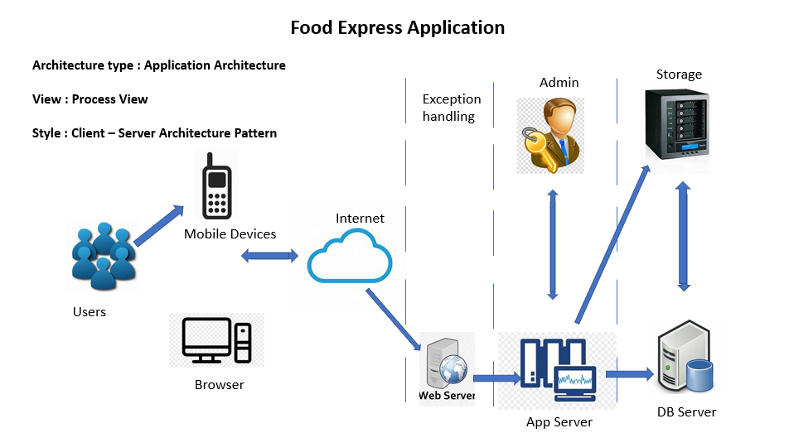

# ROLES AND RESPONSIBILITIES

The project team has eight members that are assigned various project roles including Project Manager, Product Owner, Lead Business Analyst, Lead Developer, DBA, Lead QA Analyst. Their responsibilities are defined in the table below.

|  |  |
| --- | --- |
| **Project Role** | **Role Responsibilities** |
| Project Manager | Reviewing and approving the System Test Plan, test design specifications.  Managing the test environment preparation.  Tracking the testing schedule and results. |
| Lead QA Analyst | Designing a test plan, establishing a test repository, developing test case specifications, executing testing and reporting defects. |
| Product Owner | Contributing to the test plan and test case specifications. Reviewing test results. |
| Lead Business Analyst | Contributing to the test plan and test case specifications. Reviewing test results. |
| Lead Developer | Establishing and maintaining the test environment, assisting a Lead QA Analyst throughout the testing process. |
| Developer | Assisting the Lead Developer in establishing and maintaining the test environment. |
| DBA | Assisting the Lead Developer in establishing and maintaining the test environment. |
| Tester | Responsible for designing testing scenarios for usability testing. and conducting the testing, thereafter, analyze the results and then submit observations to the development team. |

# TEST CYCLES AND SCHEDULE

The system test execution will be conducted as two test cycles that are aligned with two application modules as follows:

To add to suspicion

Cycle 1. User Experience

* This cycle concentrates on testing the first part (input and filtering) of the User Experience Module

Cycle 2. User Register/Login

* This cycle concentrates on testing the User Register/Login Module.

The schedule of the test execution cycles in the project plan:

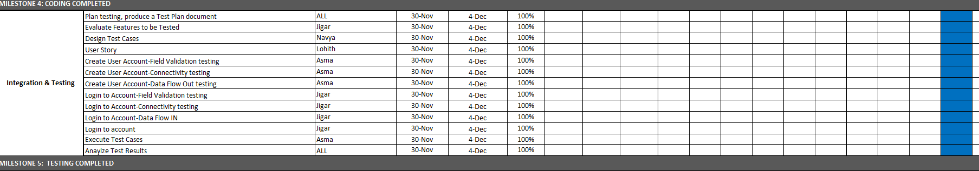

# RISKS AND CONTINGENCIES

This section highlights a few potential risks and contingencies that maybe happened during the system testing.

* Limited testing resource may result in a delay.
* Any changes on the scope objectives can cause a delay or extra work.
* Many defects require a longer time to fix defects and complete testing.
* Lack of collaboration of the team members can have a negative impact on the testing progress.
* The schedule for conducting tests may be affected by the test environment's instability.